DATA DISTRIBUTION ANALYSIS
Asim Aslam
Colorado State University Global
Course Code: MIS445-1
Professor Anwar Ahmad
Due Date

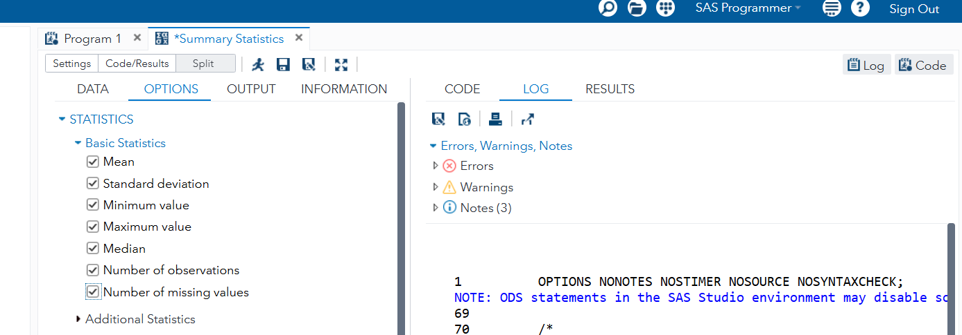
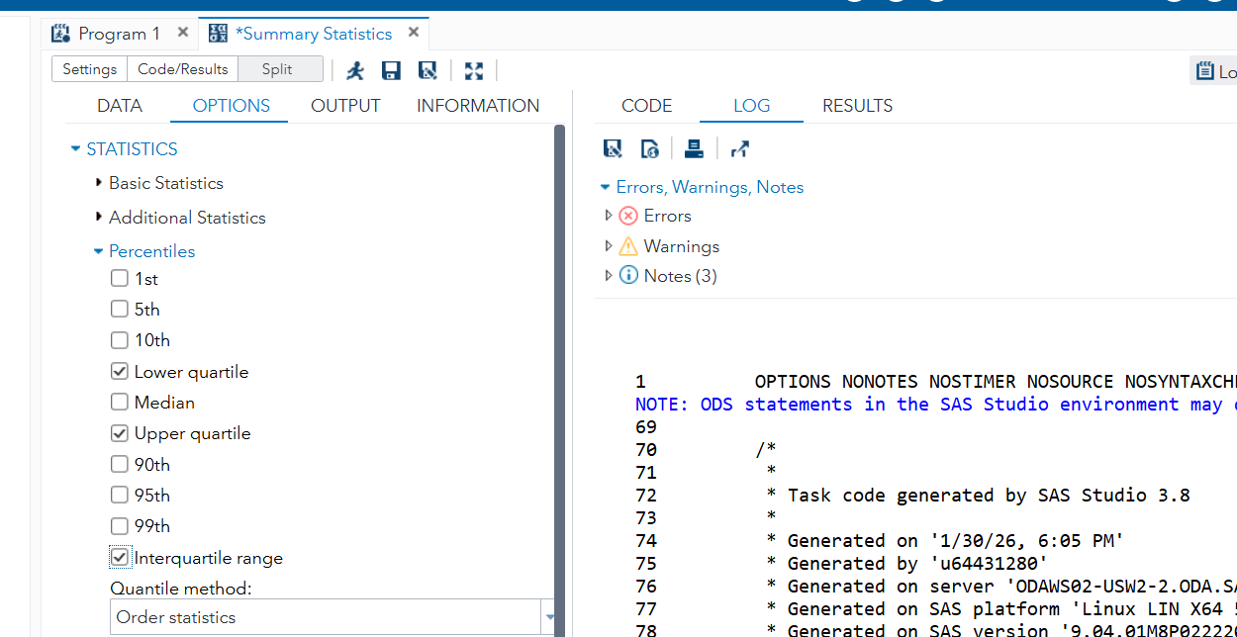
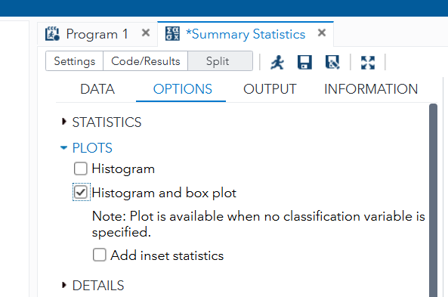
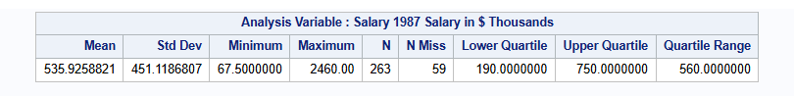
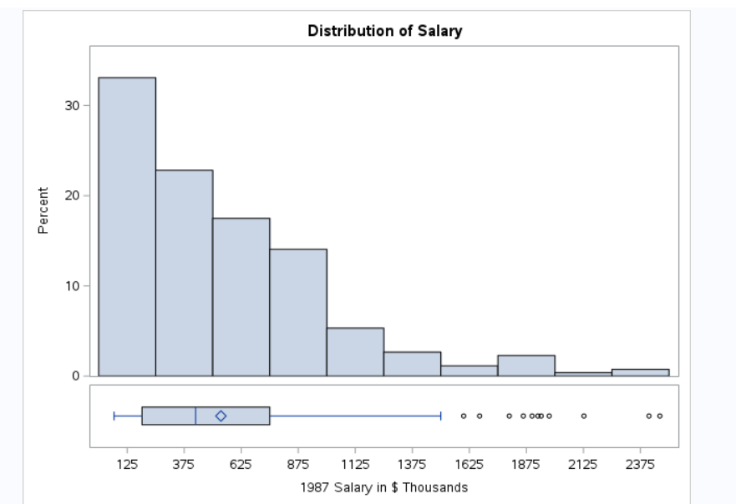

The Salary variable in the SASHELP.BASEBALL dataset shows a distribution that is clearly uneven and highly variable. Based on the summary statistics, the mean salary is 535.93 with a standard deviation of 451.12, indicating that salaries are widely spread around the average. The dataset includes 263 non-missing salary values, with 59 missing values, which means a noticeable portion of the observations do not contain salary data and are excluded from the salary calculations. Salaries range from a minimum of 67.50 to a maximum of 2460.00, demonstrating a very large gap between the lowest- and highest-paid players.
The quartile values reinforce the idea that salary levels differ substantially across players. The lower quartile (Q1) is 190.00, meaning 25% of players earn 190.00 or less, while the upper quartile (Q3) is 750.00, meaning 75% of players earn 750.00 or less. The interquartile range (IQR) is 560.00, which shows that the middle 50% of salaries span a wide band of values. This large IQR, combined with the large standard deviation, suggests there is no “typical” salary that tightly represents most players—earnings vary greatly even among the middle group.
When the histogram and box plot are considered alongside these statistics, the most likely story is that the salary distribution is right-skewed. In many real-world salary datasets, most observations cluster at lower values, while a smaller number of very high salaries stretch the distribution to the right. The maximum value of 2460.00 is far above both Q3 (750.00) and the mean (535.93), which strongly suggests the presence of high-end outliers. The box plot would be expected to show several outliers above the upper whisker, representing star players with exceptionally high earnings. Overall, this data tells a story of salary inequality in professional baseball: most players earn relatively modest salaries compared to a smaller group of top earners who raise the overall average and create a wide spread in pay.

